**Tutorial 3 Report**

**Ding Qin (A0105608L)**

**(c) Is there any statistical evidence to suggest that service satisfaction is correlated with waiting times?**

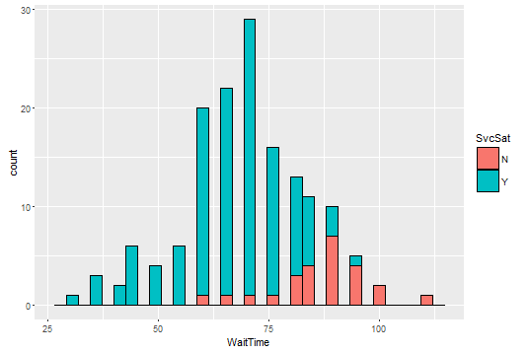

As shown in the figure above, some patients become unsatisfied when waiting time exceeds 56 mins. The number of patients who are unsatisfied with the service increases as waiting time increases.

**(d) Compute the Body Mass Index for each patient and test whether the ‘BMIs’ are correlated with ‘Total Cholesterol’**

Body Mass Index is calculated by using the formula:

Weight (in kg) / (Height (in meters) * Height (in meters))

By using a linear regression model to compare the correlation, I have obtained the following outputs:



The high R-squired value and low p-value indicates that the ‘BMIs’ are correlated with ‘Total Cholesterol’.

**(e) Predict the ‘BMI’ of a Chinese male patient whose age is 45 and SBP is 135 and TC is 150. What assumptions are necessary for the prediction to be valid?**

By using a multiple regression model, we predicted that the BMI will be 29.78424.

The R scripts used are as follows:

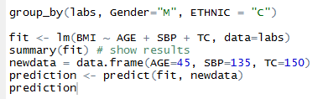

The outputs are as follows:

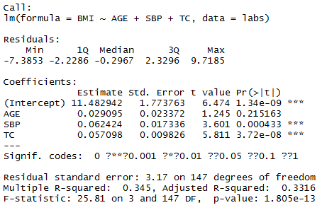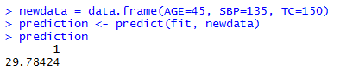

Assumptions that are necessary include that values of all other variables such as Diastolic Blood Pressure, Triglycerides and High Density Lipoprotein will not affect the value of predicted BMI.